**University of Diyala**

**Collage of Veterinary Medicine (Virology)**

**Chemical Structure of Viruses**

**A small virus has a diameter of about 20nm. Parvoviru. A large virus have a diameter of up to 300- 400nm such as, Poxviruses**.

**1-Nucleic Acid**

Viruses contain a single kind of nucleic acid -either RNA (**Ribonucleic Acid**)

Or DNA (**Deoxyribonucleic Acid**) that encodes the genetic information necessary for replication of the virus.

The nucleic acid may be single-stranded or double-stranded; it may be linear or a closed (circular); it may be segmented or non-segmented.

The nucleic acid may be single-stranded or double-stranded; it may be linear or a closed (circular); it may be segmented or nonsegmented.

RNA

Either Single stranded

Or Double stranded

Either Linear

Or Circular

Either nonsegmented

Or Segmented

**The genome of a virus can be either DNA or RNA**

**DNA-double stranded (ds): linear or circular**

**DNA- Single stranded (ss) : linear or circular(Parvoviridae)**

**RNA- ss: segmented or non-segmented**

**ss:polarity+(sense) or polarity –(non-sense)**

**ds: linear (only reovirus family)**

Most RNA virus are single-stranded- enveloped helical symmetry and replicated in the

Cytoplasm of the infected cells.

Half of the RNA viruses are

+stranded

And half are -stranded

Viral RNA exist in several forms. The RNA may be a single liner molecule (eg, Picornaviruses).

Single stranded RNA is either positive polarity (can act directly as mRNA) or negative polarity (cannot act as directly as mRNA).

Viral RNA exist in several forms. The RNA may be a single liner molecule (eg, Picornaviruses).

Single stranded RNA is either positive polarity (can act directly as mRNA) or negative polarity (cannot act as directly as mRNA).

The isolated RNA of viruses with positive-sense genome (Enveloped) (eg, Togaviruses, Coronaviruses) whereas (Non-enveloped) Picornaviruses) is infectious, and the molecule functions as an m RNA with the infected cell.

The isolated RNA of negative-sense RNA viruses, such as rhabdoviruses and orthomyxoviruses, is not infectious.

It composed of the two nucleotides of purine bases (A=adenine and G=guanine) and two nucleotides of pyrimidine bases (C=cytosine and U=uracil) while T=thymidine is not included.

**dsRNA (reo, rota)**

The size of RNA is ranged between 1.7 kb to 33kb for single stranded and from 7kbp to 27 kbp for double stranded.

We can differentiate single stranded RNA from double stranded RNA by the use of acridine orange stain.

dsRNA yellow to orange

ssRNA red to orange

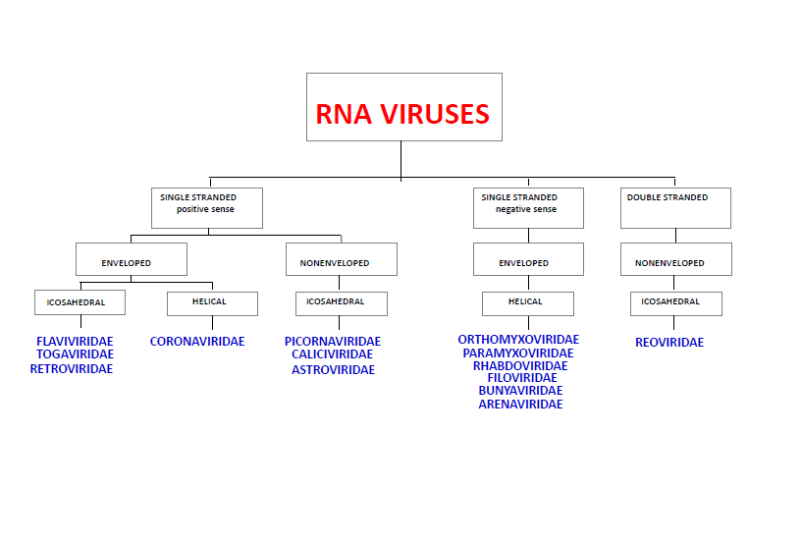

**DNA**

**Most DNA viruses are double stranded with icosahedral symmetry, and replicated in the nucleus of the infected cells, except parvovirus which was single stranded virus and pox virus which was not icosahedral symmetry and replicated in the cytoplasm of infected cells.**

Either Single stranded

Or Double stranded

Either Linear

Or Circular

**Purine Bases** **Pyrimidine Bases**

Adenine=A Thymine=T

Guanine=G Cytosine=C

While uracil from pyrimidine bases is not included

A=T

G=C

P P|

Sugar———A=T———Sugar

P P

Sugar———G=C———Sugar

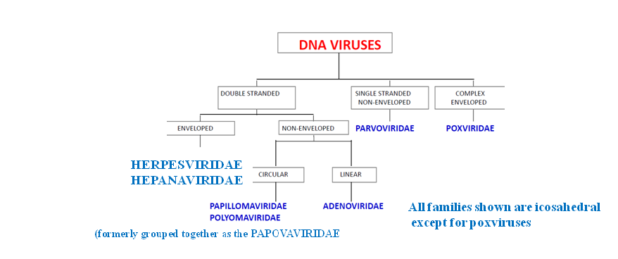

The size of viral DNA genome ranged from (3.2 kbp) (hepadnaviruses) to (375 kbp) (Poxviruses).

The size of the viral RNA genome ranges from about (7 kb) (some picornaviruses and astroviruses) to (30kb) (Coronaviruses).

All major DNA groups have genomes that are single molecules of DNA and have a liner or circular configuration.

We can differentiate ssDNA from that of dsDNA by acridine orange staining:

dsDNA Yellow-green

ssDNA red to orange

**We can differentiate RNA from DNA by the use of digestion enzymes like**

**RNAse for RNA and DNAse for DNA.**

**2-Viral Proteins**

Viral Proteins can be divided into:

**A-Structural proteins**

-They are part of the virus

-Provide a protective coat to viral NA

-They include the following proteins:-

Capsomers, nucleoproteins, receptor proteins, glycoproteins of spikes

**B- Non-structural proteins**

The nonstructural proteins associated with virions are mainly enzymes, most of which are involved in nucleic acid transcription, regulation, processing or replication. These are:

Transcriptases, Revers transcriptases, Polymerases, Ligases

**Some other proteins included the followings:**

1-Cell shutdown proteins which are produced by cytopathic RNA viruses. They prevent translation of host cell messenger RNA at the ribosomes so that viral protein may be synthesized instead.

2-DNA binding proteins

They are produced by most DNA viruses early in replication. They activated host cell DNA synthesis and thereby provide extra host catalytic enzymes for use in viral replication.

**3-Viral Lipid envelopes**

A number of different viruses contain lipid envelopes as part of their structure. The lipid is acquired when the viral necleocapsid buds through a cellular membrane in the course of maturation.They are about 20-35% of the dry weight of enveloped viruses. They are originated from host cell and conjugated into viral protein to form lipoprotein.

.

**4-Viral Carbohydrates**

Viral envelopes contain glycoproteins. In contrast to the lipids in viral membranes, which are derived from the host cell, the envelope glycoproteins are virus-encoded.

Most of them are Oligosaccharides or glycolipids or mucopolysaccharides. These carbohydrates are originated from host cells, so that cannot be considered as structural content. Their types depend mainly on the type of host cell.

Viral Antigens

Viruses may contain 4-100 structural proteins. Every member of a particular virus species will have the same number of different proteins. Each protein is different in molecular weight and function. For instance, influenza virus particles always are composed of several hundred hemagglutinins, neuraminidases, capsids, matrix and polymerase molecules.

Each viral protein usually has 1-4 different epitopes. Some of these are readily detected by serology.

Viral antigens are usually subdivided into group specific antigens which are shared by several members of a virus genus, while the serotypic antigens divided each virus group into many serotype.

The serotyping of viruses is performed by a range of tests of which neutralization is the most traditional and most likely to reveal differences.

GROUP SPECIFIC ANTIGENS

These are outside and internal viral proteins. These internal proteins are often more numerous than the external antigens and may be detected more readily by tests which depend on the numbers of antigens and antibody complexes.

Antigenic variations occurs by mutation. Genes coding for virus proteins mutate and in the case of RNA viruses one in 104-107 progeny will have an aminoacid change at one or more proteins. If the amino acid change is at an epitope then the epitope changes and different antigen is evolced.